**Lab Practice Programs**

1. **A public library maintains a record of all the books in its collection along with the number of copies available for each book. Due to high demand, some books are running out of stock. The librarian wants to generate a list(record) of such books to order more copies. Write a program to print the names of all books that have less than 2 copies available.**

**Code:**

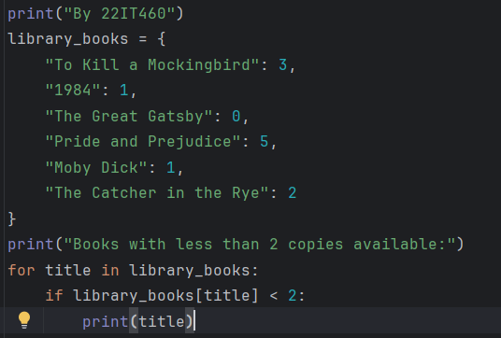

**Output:**

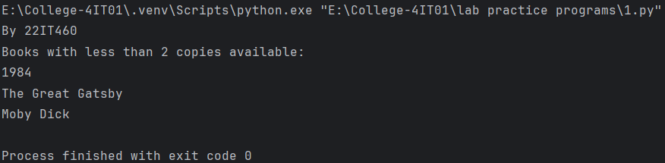

1. **A school teacher stores the marks of her students in a dictionary, where each student’s name is associated with their total marks. At the end of the examination, she wants to identify the top performer in the class to award a prize for academic excellence. Write a program to print the name of the student who scored the highest marks.**

**Code:**

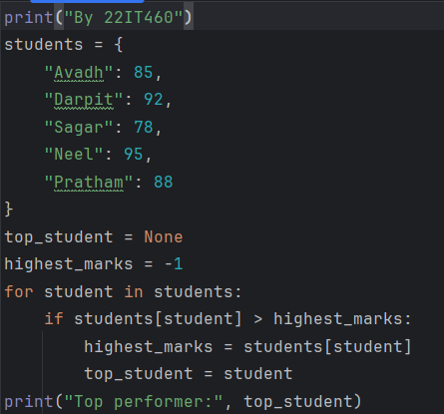

**Output:**

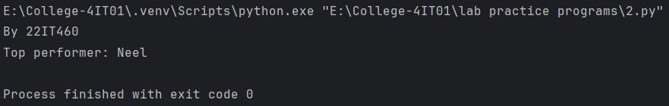

1. **An online shopping platform stores a customer’s cart items as tuples containing the item name, quantity purchased, and price per item. Before completing the checkout, the system needs to calculate the total amount the customer has to pay for their entire order. Write a program to calculate the total payable amount for all the items in the cart.**

**Code:**

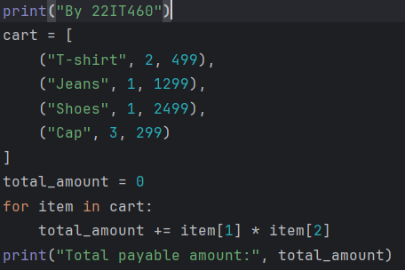

**Output:**

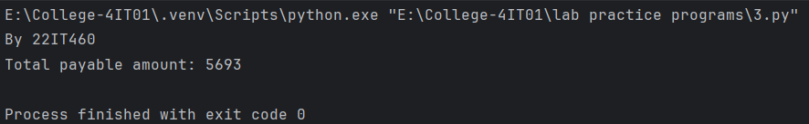

1. **A movie review website collects ratings from different users for multiple movies. Each movie may receive several ratings from different viewers. The platform wants to recommend the most popular movie to new users based on the highest average rating received. Write a program to print the movie with the highest average rating.**

**Code:**

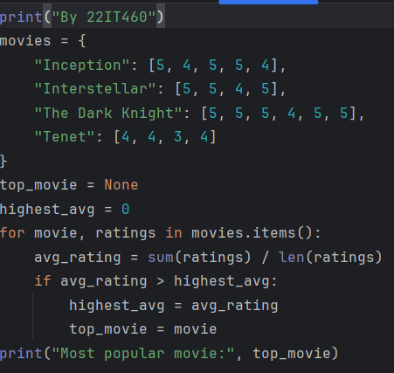

**Output:**

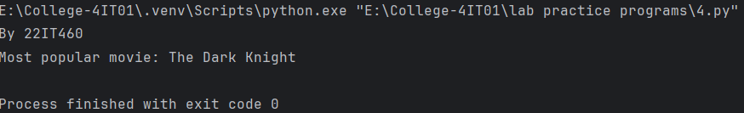

1. **A restaurant maintains its menu in a dictionary where each dish name is paired with its price. A customer searches for specific types of dishes (e.g., “Paneer”) on the restaurant’s online menu. The system needs to display all available dishes that contain the searched word, ignoring case differences. Write a program to display all dishes containing the specific word (case-insensitive).**

**Code:**

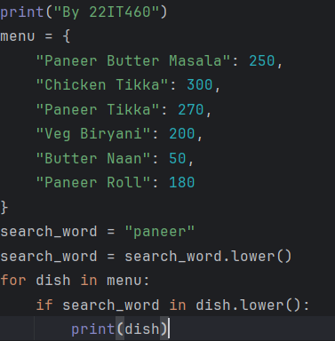

**Output:**

